**Assignment - SQL Query Joining Tables**

Shaun Pritchard

Rasmussen College

QMB4200

Terry Brookhouser

November 10, 2020

**Assignment - SQL Query Joining Tables**

This assignment I wrote an SQL query joining my two tables the INSTRUCTOR and COURSES tables while ensuring that the tables were normalized with clean results and no ambiguity.

**DB tables:**

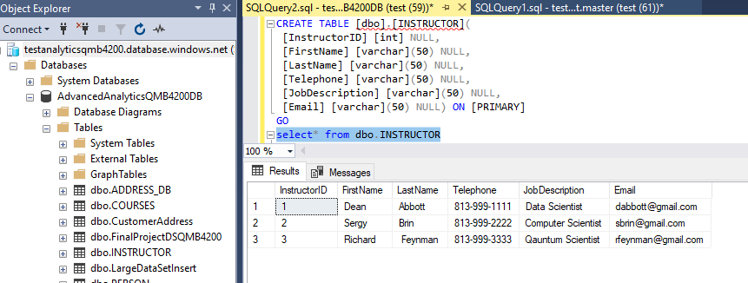

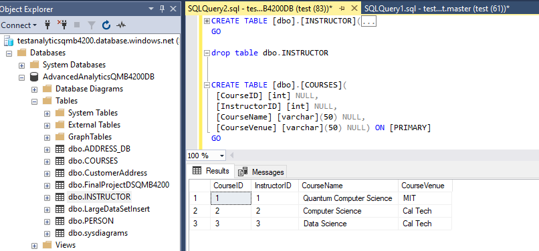

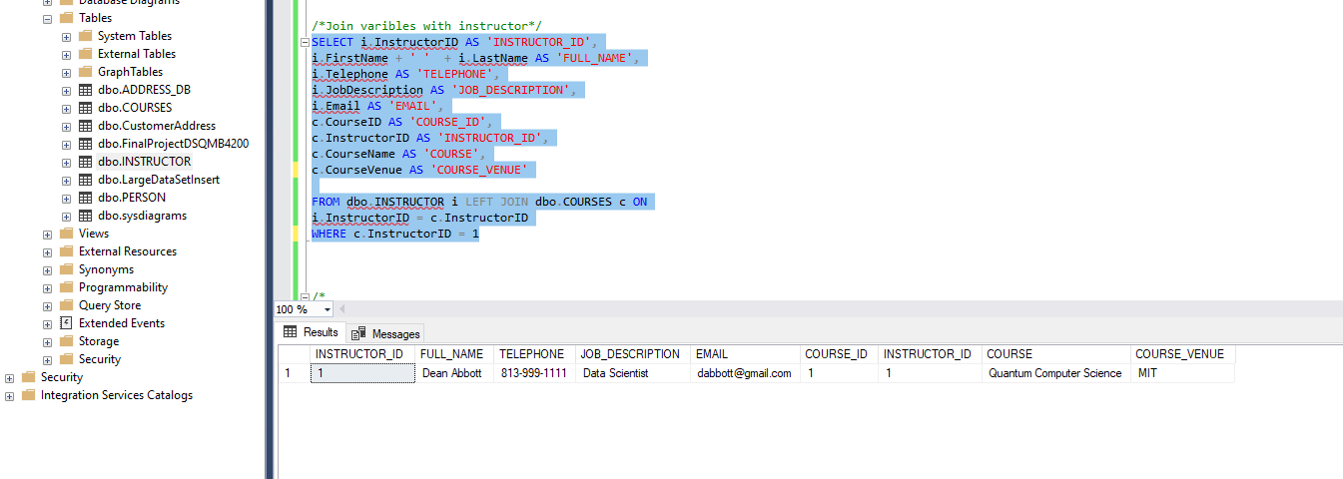

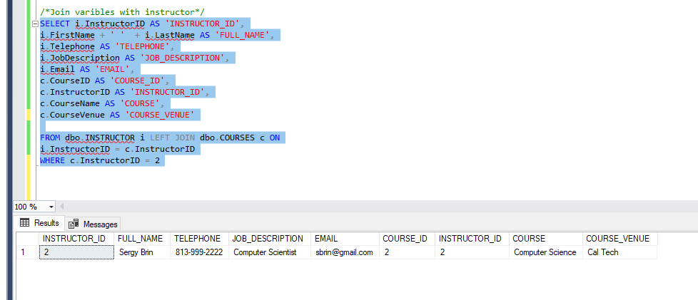

**LEFT JOIN**

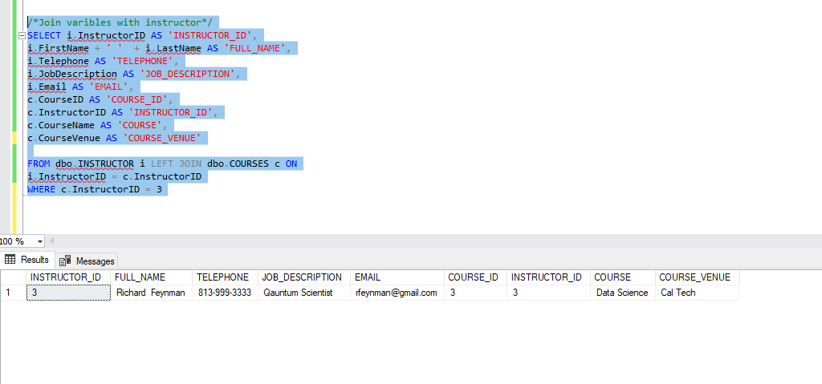

**INNER JOIN**

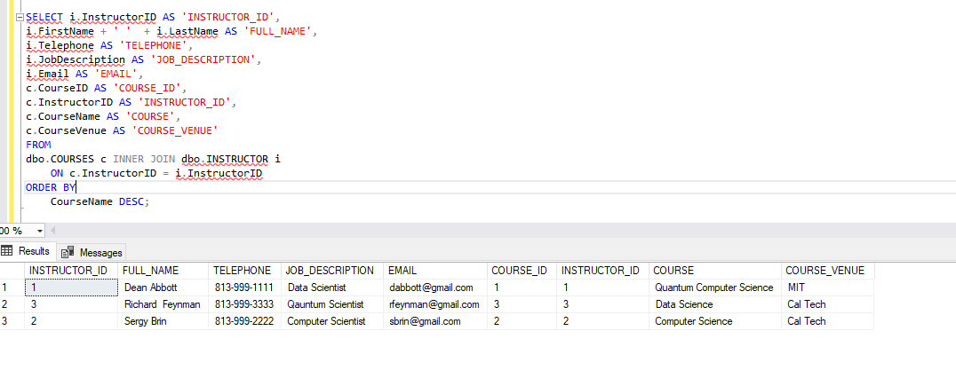

Using table aliases of COURSES and INSTRUCTORS tables I referenced the columns and used INNER JOIN to match them together in every row of COURSES. Both rows have the same value in the InstructorID column, the inner join forms a new row whose columns are from the rows of the INSTRUCTORS and COURSES tables according to the columns in the select list and includes this new row in the result set. The row in the INSTRUCTORS  table does not match the row from the COURSES  table, the inner join clause just ignores these rows and does not include them in the result set. But with this minimal set we can that it does.